International Children’s Book Day is celebrated on Hans Christian Andersen’s Birthday which is April 2nd. It is a day to celebrate books and authors from around the globe.

I am sharing some of the things I have done with my class. I cannot begin to tell you how much they enjoyed everything!

- Introduce Hans Christian Andersen to the boys and girls.
Hans Christian Andersen is from Denmark. He has written many fairy tales.
- The Princess and the Pea
- The Ugly Duckling
- The Emperor’s New Clothes
- Thumbelina... etc etc etc...

You can show the following image:
https://cdn.loc.gov/service/pnp/cph/3a40000/3a43000/3a43800/3a43817r.jpg
Info on image : https://www.loc.gov/item/2004671947/

2. Disney has taken some of the stories he wrote and made them into movies.
- The Little Mermaid
And ….

I take the following image and put it on the smartboard. I ask students to describe what they see. https://cdn.loc.gov/service/rbc/rbc0001/2003/2003juv62887/0077q.jpg

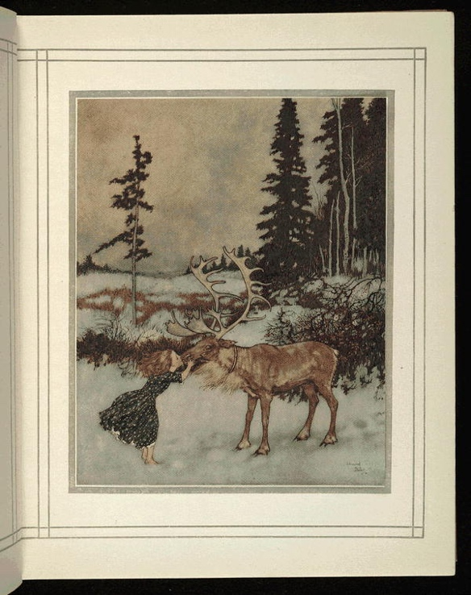

Keep asking question until the students, themselves, come to the realization that it is the story Andersen wrote and Disney made it into the movie - Frozen!

Here is a link that you can view other fairy tales and beautiful illustrations from Andersen’s stories.
https://www.loc.gov/item/84162887/

3. Adriana Rivera read - Tortillas and Lullabies, to the boys and girls in Spanish!

4. We watched the tale of Peter Rabbit written by Beatrice Potter from England

5. We watched Jack and the Beanstalk in Chinese
https://www.youtube.com/watch?v=Vw8GIf7KYLY&t=35s
and Cinderella in French
https://www.youtube.com/watch?v=_01XuvF6Eh0
and I explained children all over the world can enjoy these stories!

6. We read, Caps for Sale, written and illustrated by Russian born Esphyr Slobodkina

This week we will listen to:
1.Beauty and the Beast in German - just the beginning - no more than 5 minutes
https://www.youtube.com/watch?v=Nug2h8FUyDY
2. The Little Red Hen in Urdu
https://www.youtube.com/watch?v=F02oiU7fI0c
3. The Four Friends in Russian
https://www.youtube.com/watch?v=CiBlFME5ggQ

4. I am going to have students compare the illustrators who won the Hans Christian Andersen Award in 2018 and 2016.
Hans Christian Andersen Award for Illustration
2018 Igor Oleynikov (Russia)
2016 Rotraut Susanne Berner (Germany)

Oleynikov’s
https://www.bing.com/images/search?q=igor+oleynikov&qpvt=igor+oleynikov&FORM=IGRE

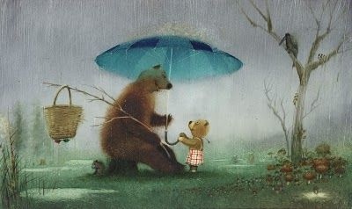

Berner’s
https://www.bing.com/images/search?q=rotraut+susanne+berner&qpvt=rotraut+susanne+berner&FORM=IGRE

